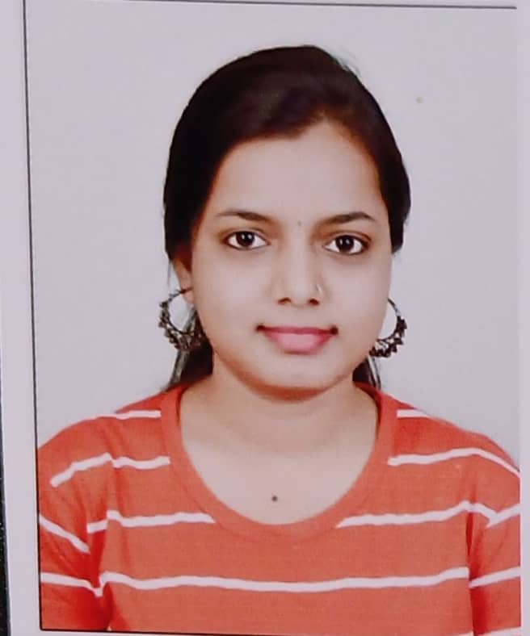

1

© Capgemini 2017. All rights reserved

|

Presentation Title | Author | Date



**Strengths**

**Achievement**

**Education and certificates**

**Base Location:**

**Email ID:**

**Mobile No:**

**Grade:**



Java 8

/J2EE

Java Basics, OOPS, Generics, Collections,

Arrays, Loops, Lambda Exp, Stream API

Junit, Mockito, Servlets

Spring

core

IOC & Dependency Injection,

Autowire

Spring

REST

REST controllers, Implementation of GET,

POST, PUT & DELETE, Bean Validation &

Exception Handling, Testing Services,

Controller & Rest template

Spring

Boot

Microservic

es

Spring Boot Starters, annotations, Messaging

Service, Sync/Async comms, Swagger API

documents

Spring

Cloud

Eureka, Netflix Ribbon, Netflix Hystrix, Netflix

Zuul & Config Server

Angular

Components, Services, Modules, Routing,

Forms & Validation, Testing using Jasmine &

Karma

Database

MongoDB No

Sql

Basics

My SQL Basics

UI Tech

HTML 5 & CSS 3,JavaScript, ES6 & TypeScript.

Tools

Git, Postman, Maven, IDE

Add On

skills

Communications, Team management. Peer

learning

**-**

**Deals and Coupons Management Application**

Completed end to end case study of Deals and Coupons

Application along with JWT authentication, Swagger .

Material

-

UI and Angular Bootstrap used for user interface.

Analyst/Software Engineer

Pune

CHAITALI.LAKSHMAN-CHAUDHARI@CAPGEMINI.COM

M

9028715861

**Full Stack Developer**

•

Hands on experience in creating

**microservices**

with

**Springboot**

**, Spring Security, Spring Cloud API**

**Gateway,**

Eureka server, load balancing.

•

Proficient in creating

**Single page Web**

Application in

**Angular**

with Authentication with route guards, Angular

reactive forms, angular routing, CSS.

•

Experience in creating documentation with Java docs and

swagger and in

**unit testing using Junit, Mockito.**

**Chaitali Chaudhari**



Check out my work on GitHub & Video Profile



A4

Master of Computer

Science (MCS)

: 2015

-

2020

**Skills**

